**Create and configure IBM Watson platform**

|  |  |
| --- | --- |
| Date | 05 November 2022 |
| Team ID | PNT2022TMID33708 |
| Project Name | Smart solutions for railways |
| Maximum Marks | 20 marks |

Step-1:Creating IBM Cloud

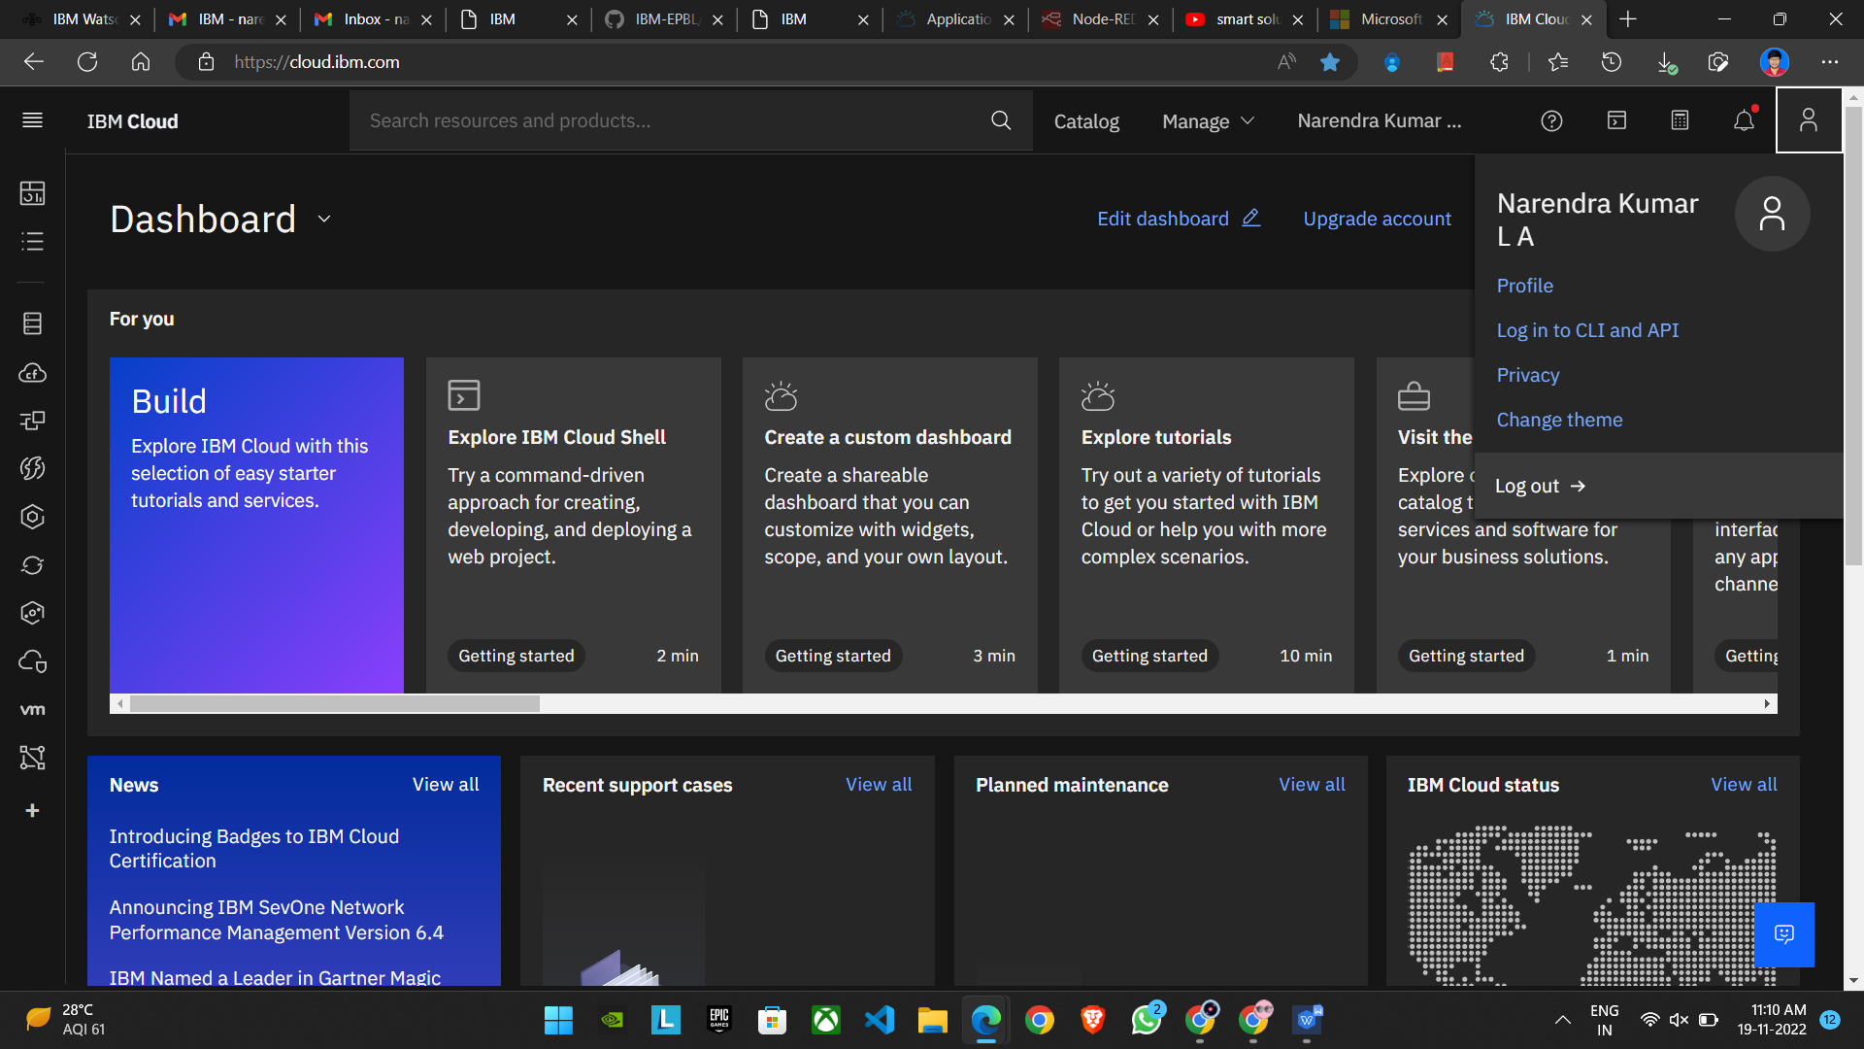

Step-2:Using IBM CLOUD services

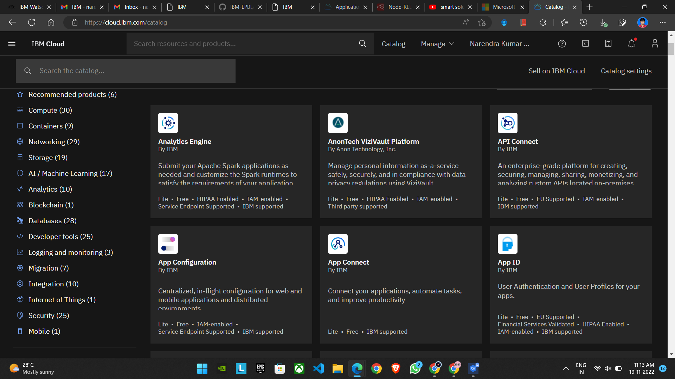

Step-3: Configure the IBM CLOUD service and creating IOT platform

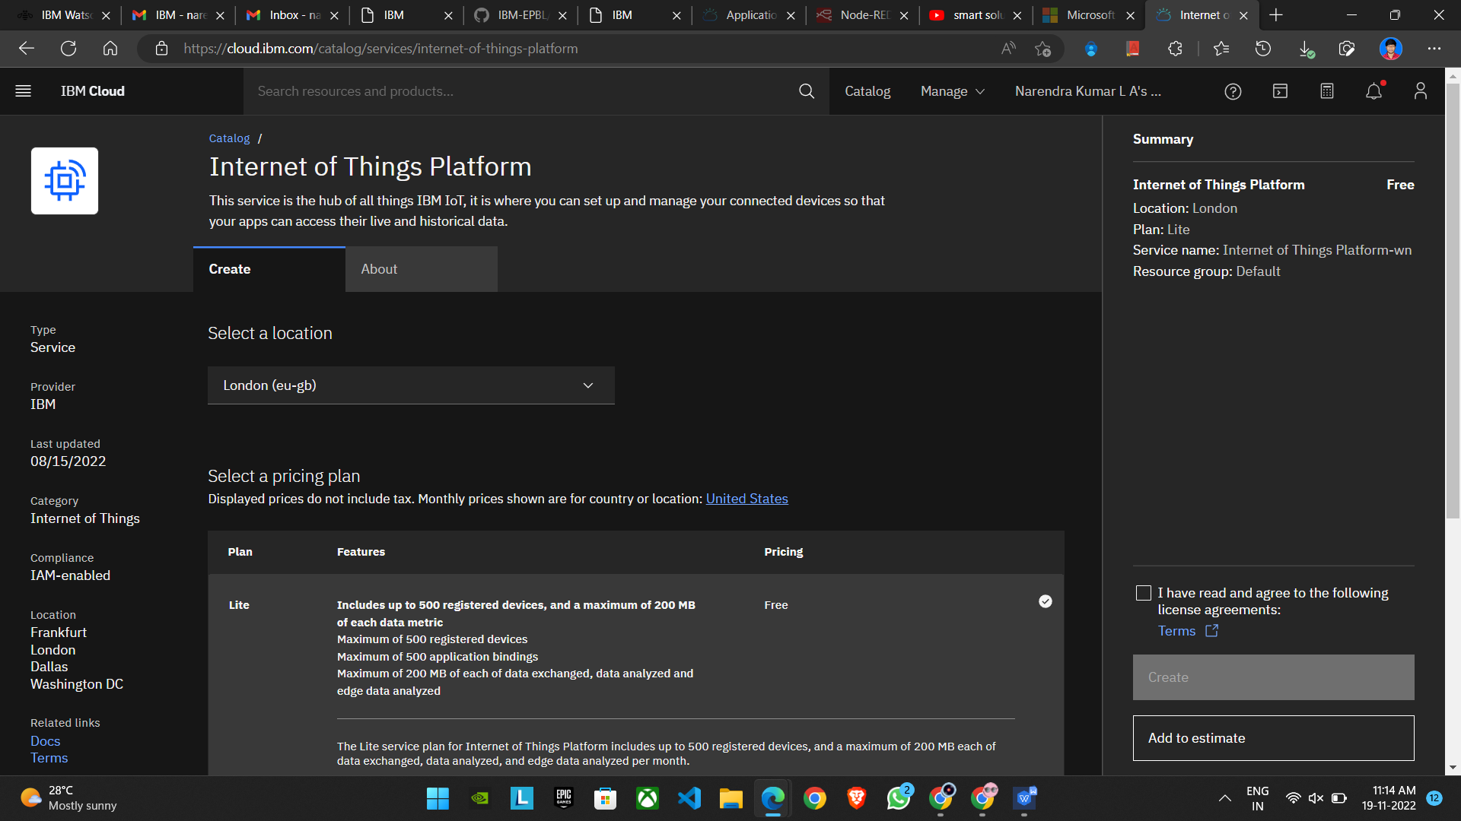

Step4:IBM Watson IOT platform acts as the mediator to connect the web application to IOT devices,hence launching IBM Watson IOT platform.

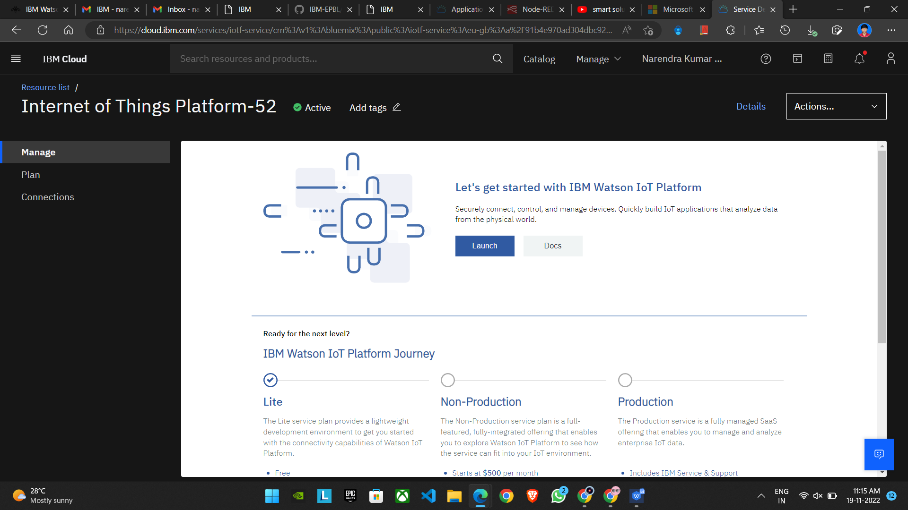

Step 5:IBM Watson IOT platform is created 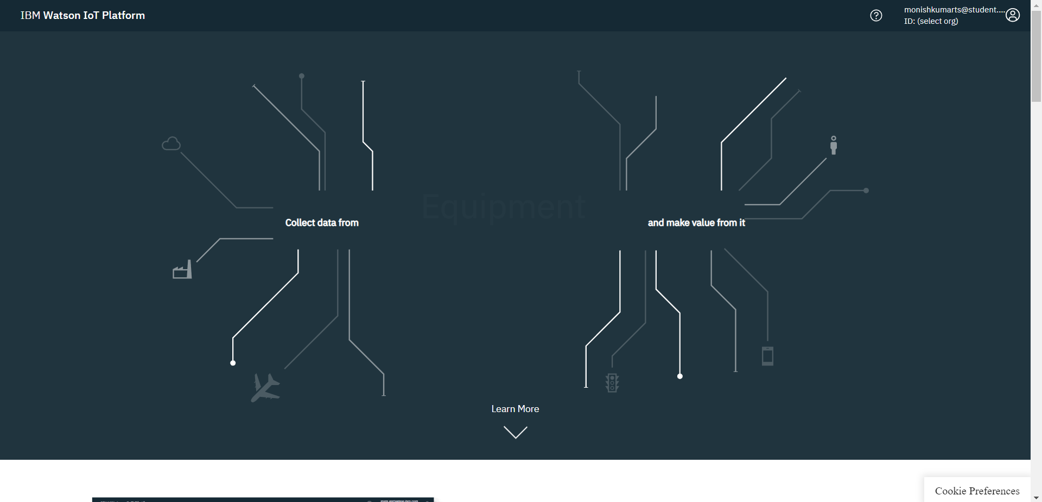 Step 6:In order to connect the IOT device to the IBM cloud,create device in the IBM Watson IOT Platform and get the device credentials.

